From: https://www.sevenforums.com/tutorials/400257-shortcut-create-relative-path.html

Windows 7: Shortcut - Create with Relative Path



Shortcut - Create with Relative Path
How to Create a Shortcut with a Relative Path
Published by Pyprohly
31 Aug 2016
Published by
Pyprohly

How to Create Shortcut having a Relative Path

Information
Shortcuts are an indisputable necessity of any user-friendly OS, and Windows is no exception. Their lingering existence make them an accustomed part of the Windows experience, providing a effortless means of navigating the file system, or launching our most used programs. They serve to boost user productivity by about 55%, and crowd desktop space by 10%.
The Windows Shortcut file, a metadata file that is interpreted by the shell, has adapted to support a number of features such as being able to
- display a custom icon,
- assign hotkeys to the link,
- store compatibility setttings including being able to run the program as administrator, link to web resources (not to be confused with .URL files), reference "magic strings" which allow linking to items inaccessible in the file system, and
- others.
These are the main reasons why symbolic links haven't yet been a suitable replacement for end-users.
Despite the diverse assortment of functionality on offer, Windows Shortcuts suffer a major disadvantage in that they are unable to reference a relative target. This means that Shortcut files are incapable of pointing to a file system item that is situated in a known directory relative to the directory in which the link was invoked, consequently preventing their portability.
Luckily, there are some work-arounds and this [August 2016 Windows 7] tutorial outlines a slew of tricks you can use to counter this restrictive limitation on Windows' part. Users wanting to use shortcuts on portable storage devices will find this tutorial especially handy.
Note
The pros and cons of each of the methods described here are summarised in the below table. Refer to this table before completing an option as you many find some options incapable for your situation. I.e., you would not want to use the Option One if you intent to use the link on a non-NTFS formatted portable storage device (symbolic links are exclusively compatible with NTFS).
CONTENTS:
- Option One: Using a Symbolic Link
- Option Two: Using a Shortcut of Window Explorer
- Option Three: Using a Batch File
- Option Four: Using a Visual Basic Script

OPTION ONE
Using a Symbolic Link

Note
Note well that symbolic links are a feature of the NTFS file system and Windows will only allow creation of a symbolic link on a NTFS formatted partition. If you wish to use this option on a portable storage device, ensure that it is NTFS formatted first.
Warning
A Win 7 symbolic link may be moved around in the same partition and while the relative path is applicable, the link will continue to work. However, one should not be tempted at any time to copy a symbolic link anywhere, or move the symbolic link across a partition. In doing so, the symbolic link will be destroyed and the resulting file will be replaced by a copy of the target.
1. Open up an Elevated Command Prompt.
2. Change the working directory to that of the folder in which you would like the link file placed. Enter the cd command as per the syntax below, appropriately replacing <directory path>. The prompt text should change to reflect the new working directory.
Code:
cd /d <directory path>
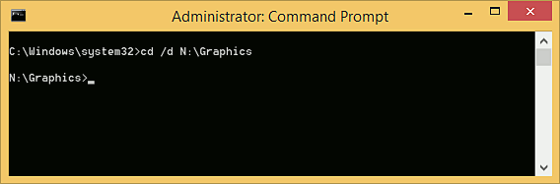
3. Do Step 4.a if your target item is a file or program, or do Step 4.b if it is a directory.
4.a Enter the following mklink command to create the link, substituting <link name> with a filename of your choice and specifying a target file or executable for <target>.
Note
The argument <link name> should not match a name that is already taken by a file in the current directory, but <target> may be any path name, whether it actually exists at the time of creation or not.
Code:
mklink "<link name>" "<target>"
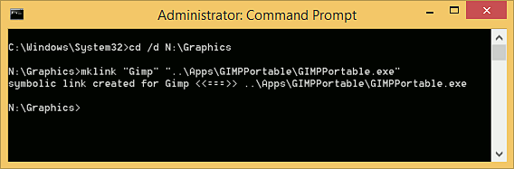
4.b Enter the below command, substituting <link name> with a filename of your choice and specifying a target directory path for <target>.
Note
The note in step 4 applies here as well. The only difference between the command featured here and that seen in step 4 is the addition of the /d switch. For more information about the mklink command enter mklink /? at the command line.
Code:
mklink /d "<link name>" "<target>"
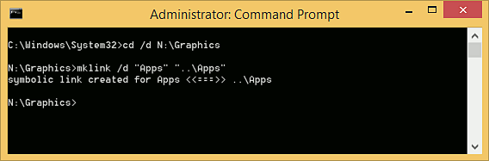

OPTION TWO
Using a Shortcut of Window [File] Explorer

Note
The Explorer program, located at C:\Windows\Explorer.exe, given any path name as an argument on the command line, will attempt to invoke the given item. Taking advantage of this, we can create an ordinary shortcut of the explorer program and pass any desired path to it and explorer will invoke that item. This path can be relative.
1. Create a new shortcut in any desired location. Right-click in a folder or on the desktop and select New -> Shortcut.
2. Enter the text "explorer" as the location for the item to create a shortcut for (as a shorthand for typing the application's full path, C:\Windows\explorer.exe).
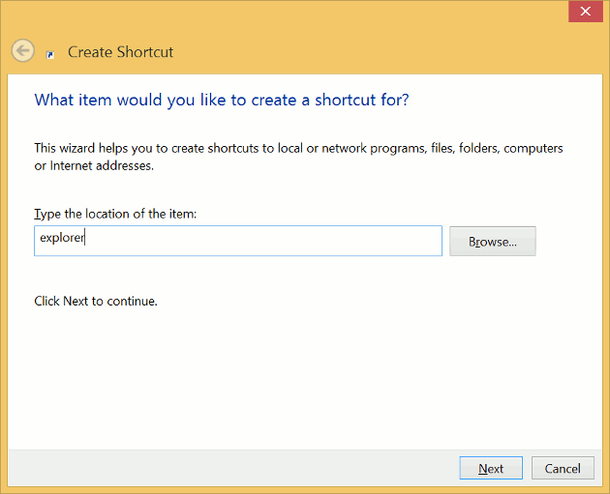
3. Enter what ever name you would like for your shortcut to display here, then click Finish.
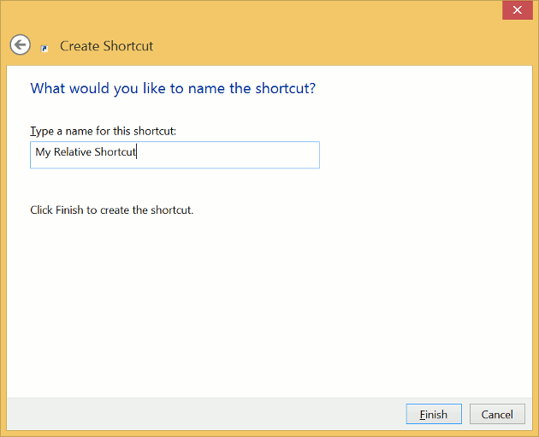
4. Right-click the new shortcut file and select Properties.
5. In the Target field, append a space to the existing text and enter the relative (or absolute) path of the folder or file that you wish to link to.
Tip
If this path is relative it will be relative to the directory of which the shortcut file itself resides only if the Start in field is empty, else if the Start in field is populated with a valid path name the path here will be used as the base path for the path you've entered in the Target field.
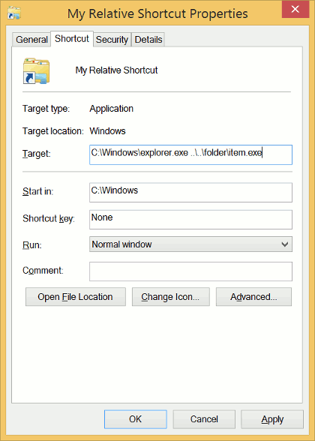
6. Remove all text in the Start in field. Alternatively, you may type an absolute path here and this path will be used as the base path for the relative path youï¿½ve entered as an argument in the Target field. You may close the Properties pane now.
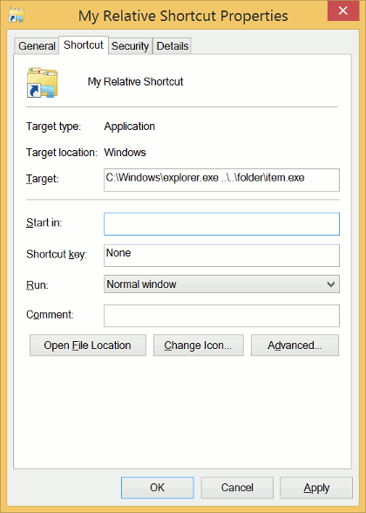
7. Check if your link works. Double-click your new relative shortcut. If your userï¿½s Documents folder opens up instead of the item you intended to link to, the item could not be found and you should check that you've completed Steps 5 and 6 correctly.

OPTION THREE
Using a Batch File

Note
Although flexible and easy to manage this option may not be preferable due to the unsightly quick flash of a command prompt screen each time the link is accessed.
1. Open Windows Notepad or your preferred text editor.
2. Append an "@echo off" line to begin the batch file with.
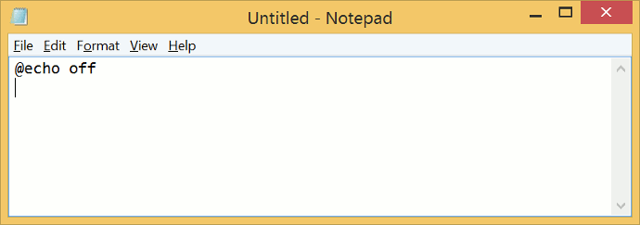
3. If you intend to link to an application and wish to artificially alter the working directory for it, add a cd line like below, where <target> is the path of a directory, else skip this step.
Code:
cd /d <target>
4. Follow with a series of start commands, using the syntax presented. <target> may be a directory or file relative path name.
Tip
%~dp0 represents the path of the batch file. If youï¿½d like your target to be relative to the root directory instead, remove the %~dp0 part.
Code:
start "" "%~dp0\<target>"
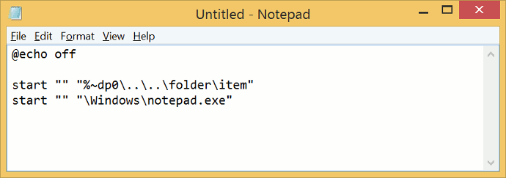
5. Save the file to a location of your choice and give it an extension of .bat.

OPTION FOUR
Using a Visual Basic Script

Note
This option may feel particularly slow if many Explorer windows are open.
1. Download the VBS_Shortcut.vbs file with the provided link.
VBS_Shortcut.vbs

2. Open the downloaded VBScript file with Notepad or your preferred text editor.
3. Locate lines 16 and 17 and adjust the string values appropriately, with "Target" being the relative path of the item you wish to link to and "WorkingDirectory" being the working directory for your application. Leave this value blank if you don't require the application's working directory be altered.
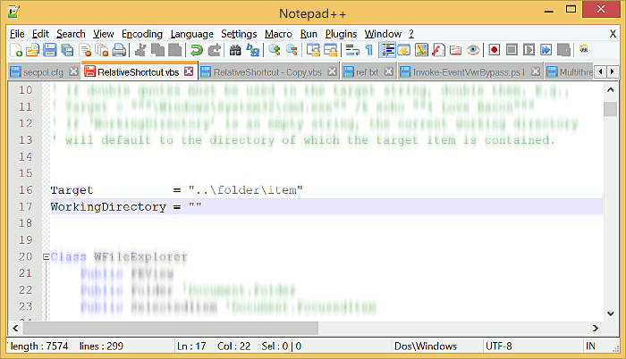
That's all. Got a question, query, suggestion, or recommendation? Please let me know in the section below right away.
Enjoy,
Pyprohly
Related Tutorials

- How to Create a Shortcut of a File, Folder, Drive, or Program in Vista, Windows 7, and Windows 8



Shortcut - Create with Relative Path

« Previous Thread | Next Thread »

Similar help and support threads
Thread | Forum
Relative path shortcuts help  Hello. I have a large number of folders and shortcuts on an external drive. Example: Folder 1 - Folder A - Folder B Folder 2 - Folder A - Folder B | General Discussion
Custom 'Desktop (create shortcut)' Remove .fileextension - Shortcut  Hi guys n girls, I have for ever got sick and tired of right click -> open Send to Menu and creating a Desktop Shortcut for a file or app....then needing to go to the Desktop right click the newly made shortcut and then removing the trailing file extension, dash and words shortcut in brackets.... | Customization
Shortcut problem (relative path)  Hi everyone, Someone know how I could change my shortcut path, regardless of the machine ? My picture is in C:\Users\Manon\Desktop\perso\1.png. I made some research, I have to change the "Start in" in the properties of the shortcut. But what I have to write in ? Thanks for your advices,... | General Discussion
Shortcut in a path breaks hyperlink  Hi, I have the situation where a directory path has changed and I have emails that have hyperlinks to files (in the emails) that point to the old path. In my old Unix days I would have just created a link using ln command. In Windows I can create a shortcut to the old directory (which works in... | General Discussion
broken path all shortcut  helo everybody.. i have a problem that all my icon window seven have broken path include control panel icon..can u all help me how to fix and repair the path shortcut..all shortcut only can open with 1 program..its cannot by their program self..helppss:cry:... | BSOD Help and Support

Our Sites | Site Links | About Us | Find Us
- Vista Forums  - Eight Forums  - Ten Forums  - Network Status | - Contact Us  - Legal  - Privacy and cookies | Windows 7 Forums is an independent web site and has not been authorized, sponsored, or otherwise approved by Microsoft Corporation. "Windows 7" and related materials are trademarks of Microsoft Corp.  © Designer Media Ltd  All times are GMT -5. The time now is 13:55.

Query
what, in Windows, is the equivalent of the Unix ln -s command?

Symlink

From: http://desktop.arcgis.com/en/arcmap/10.3/tools/supplement/pathnames-explained-absolute-relative-unc-and-url.htm

Avoiding Platform Depedent Code
http://www.mit.edu/~6.005/fa09/resources/avoid-dependent-code.html

Paths explained: Absolute, relative, UNC, and URL
ArcMap 10.3
|
Other versions
- Paths and pathnames
- Absolute and relative paths
- Absolute and relative paths in ArcMap
- Absolute and relative paths in model tools
- Absolute and relative paths in script tools
- Why use relative versus absolute paths?
- UNC paths
- URLs
- ArcSDE connection file path
You deal with paths every day to browse to your data and toolboxes. This topic delves into detail about paths, defining the different types, and how ArcGIS manages them.

Paths and pathnames

Path
A path is a slash-separated list of directory names followed by either a directory name or a file name. A directory is the same as a folder.
E:\Data\MyStuff (path terminating in a directory name)
E:\Data\MyStuff\roads.shp (path terminating in a file name)

Pathname
On occasion, you may see the term pathname or path name. Path, pathname, and path name are synonymous.

System versus catalog path
ArcGIS uses the term catalog path or ArcCatalog path. A catalog path is a path that only ArcGIS recognizes. For example:
D:\Data\Final\Infrastructure.gdb\EastValley\powerlines
refers to the powerlines feature class found in the EastValley feature dataset in the file geodatabase Infrastructure. This is not a valid system path as far as the Windows operating system is concerned, since Windows doesn't recognize feature datasets or feature classes within a file geodatabase. Of course, everything in ArcGIS can operate with catalog paths.

Workspace and base name
Catalog paths consist of two parts: the workspace and the base name, as illustrated below:
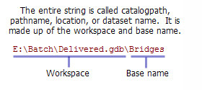

Location
Location is a catchall term for path, as in "Browse to the location of your data" or "Enter the location of your data."

Forward versus backward slashes
The Windows convention is to use a backward slash (\) as the separator in a path. UNIX systems use a forward slash (/). Throughout ArcGIS, it doesn't matter whether you use a forward or backward slash in your path—ArcGIS will always translate forward and backward slashes to the appropriate operating system convention.

Backward slash in scripting
Programming languages that have their roots in UNIX and the C programming language, such as Python, treat the backslash (\) as the escape character. For example, \n signifies a carriage return. Since paths can contain backslashes, you need to prevent backslashes from being used as the escape character. A common technique is to escape the backslash, as follows:
thePath = "E:\\data\\telluride\\newdata.gdb\\slopes"
Another way is to convert paths into Python raw strings using the r directive, as shown below. This instructs Python to ignore backslashes.
thePath = r"E:\data\telluride\newdata.gdb\slopes"

Absolute and relative paths

Absolute, or full, path
An absolute, or full, path begins with a drive letter followed by a colon, such as D:.

Relative path
A relative path refers to a location that is relative to a current directory. Relative paths make use of two special symbols, a dot (.) and a double-dot (..), which translate into the current directory and the parent directory. Double dots are used for moving up in the hierarchy. A single dot represents the current directory itself.
In the example directory structure below, assume you used Windows Explorer to navigate to D:\Data\Shapefiles\Soils. After navigating to this directory, a relative path will use D:\Data\Shapefiles\Soils as the current directory (until you navigate to a new directory, at which point the new directory becomes the current directory). The current directory is sometimes referred to as the root directory.
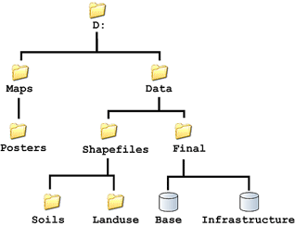
If you wanted to navigate to the Landuse directory from the current directory (Soils), you could type the following in the Windows Explorer Address box:
..\Landuse
Windows Explorer would navigate to D:\Data\Shapefiles\Landuse. A few more examples using D:\Data\Shapefiles\Landuse as the current directory are below:
.. (D:\Data\Shapefiles)
..\.. (D:\Data)
..\..\Final (D:\Data\Final)
. (D:\Data\Shapefiles\Landuse - the current directory)
.\..\Soils (D:\Data\Final\Soils)
..\..\.\Final\..\Shapefiles\.\Landuse (D:\Data\Shapefiles\Landuse)

Note:
You cannot type relative paths (using the dot and double-dot notation) in any ArcGIS application.
A relative path cannot span disk drives. For example, if your current directory is on drive D, you cannot use relative paths to navigate to any directory on the E drive.

Absolute and relative paths in ArcMap
When you create an ArcMap (or ArcScene or ArcGlobe) document, you can specify that paths will be stored as relative paths. To set this option, look under the File menu and click Map Document Properties. Here, you can specify whether to store absolute or relative paths.
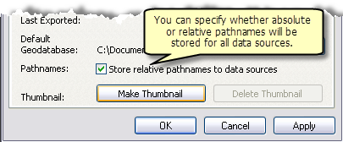
When you save the document with relative paths, the application converts paths into relative paths (using the dot/double-dot notation) relative to the location where you stored the document (the current directory). For example, if your document is stored in
D:\Maps\Posters\Newmap.mxd
and the data in one of your layers is
D:\Data\Final\Infrastructure.gdb\Streets
what gets stored in Newmap.mxd is the following:
..\..\Data\Final\Infrastructure.gdb\Streets
When you open Newmap.mxd again, ArcMap converts the stored relative path from the dot/double-dot notation back into the absolute path representation, which is displayed as the data source for a layer. This conversion is always relative to the location of the map document (the current directory).

Only paths on the same disk are converted
Relative paths cannot span disk drives. That is, if the root directory is on drive D, you cannot use relative paths to navigate to a directory on drive E. When you store your map document using relative paths, only those paths that are on the same drive are converted and stored.
Learn more about referencing data in a map document

Absolute and relative paths in model tools
Just like data in ArcMap, you can specify that paths in your model tools will be stored as relative paths.
The current directory used for relative paths is the directory where the tool's toolbox resides. The relative path option converts and stores paths to the following:
- Data in a model
- Graphic images in a model
- Tools used in your model
- Files referenced in tool metadata and help
- Style sheets
- Layer files (.lyr) used for symbology
- Compiled help files (.chm)
To store as relative paths, right-click the model tool, click Properties, then click the General tab. At the bottom of the dialog box, check Store relative path names (instead of absolute paths), as shown below.
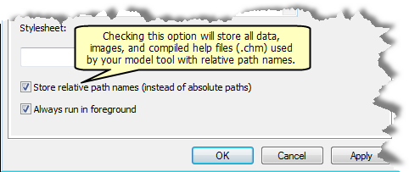

Only paths on the same disk are converted
Relative paths cannot span disk drives. That is, if the root directory is on drive D, you cannot use relative paths to navigate to a directory on drive E. When you store your model using relative paths, only those paths that are on the same drive are converted and stored.

Absolute and relative paths in script tools
When using the Add Script wizard, the option to store relative paths will appear on the first panel. You can also set this option by right-clicking the script tool, clicking Properties, then clicking the General tab. At the bottom of the dialog box, check Store relative path names (instead of absolute paths).
The current directory used for relative paths is the directory where the tool's toolbox resides. The relative path option converts and stores paths to the following:
- The script
- Datasets used for the default value property
- Files referenced in tool metadata and help
- Layer files (.lyr) used for the symbology property
- Compiled help files (.chm)
- Style sheets

Only paths on the same disk are converted
Relative paths cannot span disk drives. That is, if the root directory is on drive D, you cannot use relative paths to navigate to a directory on drive E. When you store your script tool using relative paths, only those paths that are on the same drive are converted and stored.

Paths within the script are not converted
You cannot use the dot and double-dot notation in scripts. For example, the following will not work:
arcpy.AddField_management("..\redlands.mdb\streets", "ref_ID", "long", "9", "#", "#", \
"refcode", "NULLABLE", "REQUIRED", "#")
because ..\redlands.mdb\streets is a relative path.

Why use relative versus absolute paths?
Using absolute paths, the following are true:
- You can move the document or toolbox anywhere on your computer and the data will be found when you reopen the document or tool.
- On most personal computers, the location of data is usually constant. That is, you typically don't move your data around much on your personal computer. In such cases, absolute paths are preferred.
- You can reference data on other disk drives.
Using relative paths, these adjustments are necessary:
- When moving a map document or toolbox, you must also move the referenced data.
- When delivering documents, toolboxes, and data to another user, relative paths should be used. Otherwise, the recipient's computer must have the same directory structure as yours.
For example, consider the directory structure below. In this example, D:\Tools\Toolboxes\Toolbox1 contains a script tool that uses D:\Tools\Scripts\MyScript.py.
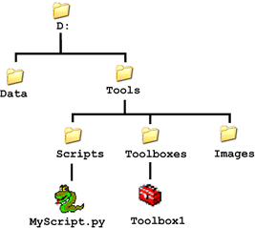
Using absolute paths, if you moved the toolbox from D:\Tools\Toolboxes\Toolbox1 to a different disk, such as E:\Final\Toolbox1, ArcGIS will find D:\Tools\Scripts\MyScript.py and everything will work fine. If, however, you use relative paths, ArcGIS will not find the script and the tool will not work. The tool dialog box will open, but when you execute, you'll get the error message "Script associated with this tool does not exist." You will have to open the tool's properties and enter the correct path to the script.
On the other hand, if you use relative paths, you can simply copy the folder D:\Tools anywhere on anyone's computer and everything will work. This won't work if you use absolute paths, because the recipient could copy the folder to F:\NewToolsand the path D:\Tools\Scripts\MyScript.py won't exist on his or her computer.

Summary
- Relative paths cannot span disk drives.
- Absolute paths work best when data isn't moved, which is typical for disks on a personal computer.
- Relative paths work best when you're delivering documents and data to another user.
- Relative paths use dot/double-dot (. and ..) notation. You can enter relative paths with this notation in Windows Explorer or at the Windows command prompt.
- ArcGIS doesn't allow you to enter relative paths using dot/double-dot notation. Rather, relative paths are stored in the document or toolbox (once you check the Store relative path names option).
- Relative paths are relative to a current directory, which is the location of the saved document or toolbox.

UNC paths
UNC stands for Universal (or Uniform or Unified) Naming Convention and is a syntax for accessing folders and files on a network of computers. The syntax is as shown:
\\<computer name>\<shared directory>\
followed by any number of directories and terminated with a directory or file name.
For example:
\\pondermatic\public\studyarea.gdb
\\omnipotent\shared_stuff\wednesday\tools
The computer name is always preceded by a double backward slash (\\).
In UNC, the computer name is also known as the host name.
These are a few rules for UNC paths:
- UNC paths cannot contain a drive letter (such as D).
- You cannot navigate to directories above the shared directory.
- The Store relative path names option for documents and tools has no effect on UNC paths.
In ArcGIS, you can use a UNC path anywhere a path is requested. This is particularly advantageous for shared data on a local area network (LAN). Data can be stored on one computer and everyone with access to the computer can use the data, as long as the computer is not turned off or removed from the network.
In Windows, you can share a folder so that other users on your local area network can access it. In ArcCatalog or Windows Explorer, right-click a folder, click Sharing and Security, then follow the instructions on the dialog box that opens.

URLs
URL stands for Uniform Resource Locator and uniquely specifies the address of any document on the Internet. The components of a URL are these:
- The protocol used to access the resource, such as HTTP (Hypertext Transfer Protocol) or FTP (File Transfer Protocol)
- The host (server) to communicate with
- The path to the file on the host
For example:
http://www.esri.com/products.html
Windows Internet Explorer allows you to type www.esri.com in the Internet Explorer address bar, and it will automatically add http://. It's more correct, however, to specify the protocol, such as http. Other protocols include HTTPS (Secure Hypertext Transfer Protocol), FTP, mailto (e-mail address), and news (Usenet newsgroups), among others.
In ArcGIS, you can only use URLs where permitted. In general, the user interface will tell you whether a URL is permitted or needed. When using URLs in ArcGIS, it's recommended that you include the protocol, as in
http://www.esri.com
rather than
www.esri.com

ArcSDE connection file path
Geoprocessing tools use the path to an ArcSDE connection file (.sde) to locate data stored in an ArcSDE database.
D:\Data\Final\Connection to ArcSDE.sde\EastValley\powerlines
The connection information in the .sde file is used to create a connection to ArcSDE, and the geodatabase looks up the data being requested in the same way as it does for file or personal geodatabases (see above).

Related Topics
- Setting paths to data in Python

